Lab 6.1 Working with Labels

1. Create a pod with labels “environment=staging” and “team=kube-team” using a pod-definition.yml file

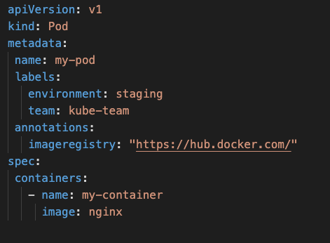

* 1. Create the POD using the manifest file

**cd <yaml folder>**

**kubectl create -f pod-definition.yml**

1. Check that the labels are applied in the newly created pod:

**kubectl get pod my-pod --show-labels**

1. Add a label to a pod using Kubectl:

**kubectl label pod my-pod versionID=ver0.9**

1. Remove a label from a pod using Kubectl:

**kubectl label pod my-pod versionID-**

1. Update a label for a pod using Kubectl:

**kubectl label --overwrite pods my-pod team=ops**

1. Create an nginx deployment called myapp with two replicas and a label env =dev

**kubectl run myapp --image=nginx --labels=”env=dev”**

1. Create another nginx deployment called myapp2 with two replicas and a label env=prod

**kubectl run myapp2 --image=nginx --labels=”env=prod”**

1. View deployments with their respective labels displayed.

**kubectl get pods --show-labels**

1. Let’s view a deployments labels env=dev from our previously created deployment.

**kubectl get pods -l env=dev --show-labels**

**kubectl get pods --selector=”env=dev” --show-labels**

1. View all pods with labels env=dev and env=prod.

**kubectl get pods -l 'env in (dev,prod)' --show-labels**

**kubectl get pods --selector="env in (dev, prod)" --show-labels**